**Super Cool Bricks – Report**

I am impressed with final quality of the game I have made. It is a polished brick breaker game with a catch and release system and collision that changes depending on where the ball hits each brick. While I would like to spend more time on it and add some features such as brick health (likely by adding another variable to my brick function) I feel that the project I am submitting is at an excellent standard and to my knowledge bug free.

Pros:

* Responsive gameplay
* Bricks have different collision depending on where the ball collides with them
* The game starts with the ball hovering over the paddle and the player is able to move and release the ball with space bar
* Good chance that each game will be different
* Clean and aseptically pleasing looking game
* Game is different playthrough as long as you move the paddle before pressing space
* The game has endless levels meaning gaining the highest score is desirable as the higher the level the higher the points multiplier on the score
* Game is very efficient; each level uses the same amount of ram so even if a player played to level 100 the game would have no slowdown (this is due to bricks being removed when destroyed)
* Visually appealing CSS and HTML layout

Cons:

* More complex features could be added e.g. health, sound, different brick layouts
* Perhaps too many global variables were used and the program could be made cleaner with some cutting down.

Originally I had a very simple collision detection system which only responded when a brick was hit regardless of where the brick was hit, however, I quickly upgraded this to a new collision system which knows the difference between the top/bottom/left and right of the brick being hit. This was by far the most complicated part of my code and I encountered multiple logic errors until I finally got the game to do what I wanted. It was however I useful learning experience.

While I believe it may have also benefited the game if I also made the same kind of collision for the paddle I desided that this would add very little to the game overall as the sides of the paddle behing it would be rare and mostely just annoying.

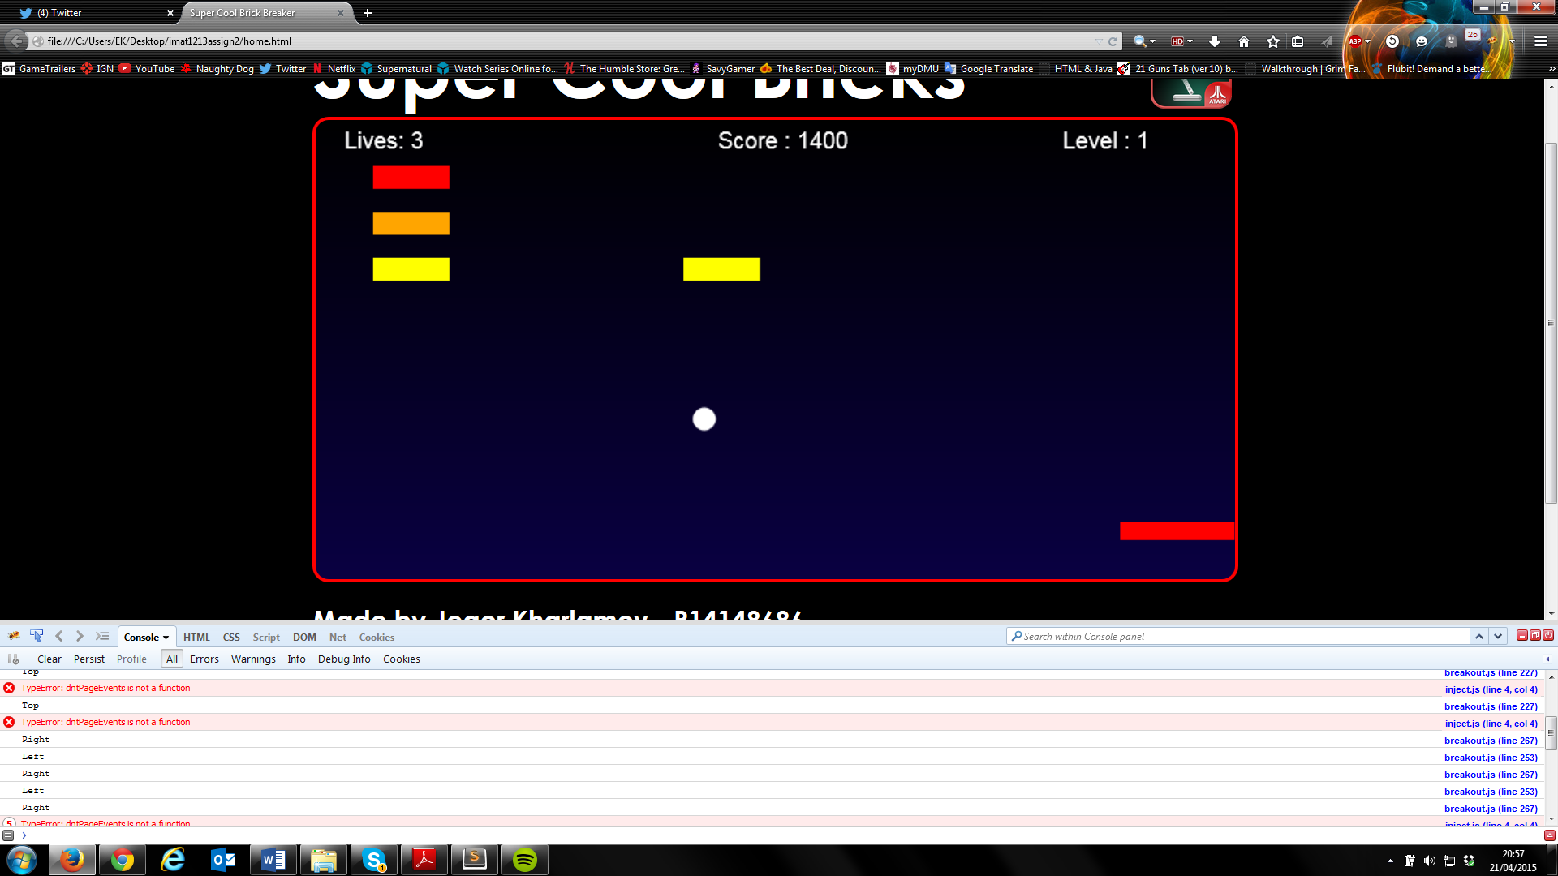

Above is an example of the code being written out if as a ball bounces through the gaps of my bricks if I tell it to console log each collision.

If I had more time and experience with Javascript I would have liked to have expanded my code futher by including multiple hit bricks, different brick layouts and potentially even power-ups.

Please note that the game is fully functional on firefox and chrome but seems to fail to load anything on internet explorer. After some research I have found this to be due to internet explorer having a rather bizzare and outdated javascript understand that required its own commands. Potentially as another expantion I would like the game to function on IE aswell.

Extra features my game has:

* Multiple (unlimited) levels that multiply the score and increase ball and paddle speed
* Ability to ‘hold’ the ball before release by pressing spacebar
* Brick collision is dependent on which point of the brick is hit